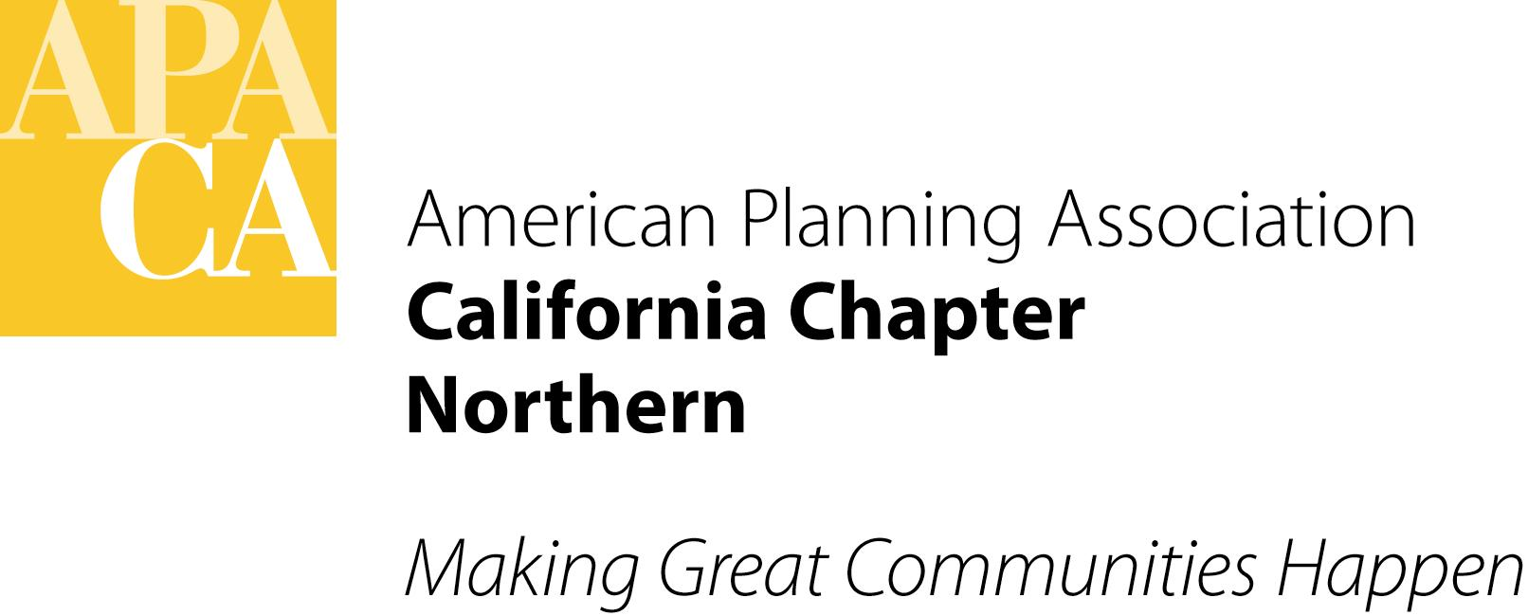APA California Northern
MENTORSHIP PROGRAM
2015 Mentee Application
Thank you for your interest in APA California Northern Section’s Mentorship Program. This Mentorship Program will run from January 2015 to October 2015. The following information will be used to help match you to a mentor. Please attach your resume to this application. Participant applications are due to Thalia Leng, thaliah@gmail.com, by Tuesday, January 6, 2015. Visit the Section’s website (www.norcalapa.org) for more details on the Mentorship Program.

Name: APA Membership Number:
Email: Phone Number:
Home Address:
City: Zip Code:

Were you involved as a mentee in the previous Mentorship Program? Yes No
If yes, would you like to be matched up with your previous mentor? Yes No
What are you looking for in a mentor?

Do you have any geographic/time constraints? Yes No
If yes, please describe:
How far are you willing to travel to meet with a mentor? _____ miles
How do you rank the following (1 as most desired and 3 as least desired):
_____ proximity to mentor _____ align schedule with mentor _____ similar areas of expertise

EMPLOYMENT

Current Employer and Position:
Length of Time in this Position:

Previous Employer and Position:
Length of Time in this Position:

Education (Post High School)

School Attended or Attending:
Date Graduated: Degree Earned:

School Attended or Attending:
Date Graduated: Degree Earned:

APA California Northern Mentorship Program | Mentee Application – Page 2

Please describe your short (1-2 years) and long (3-5 years) term career goals:

What kind of skills or knowledge do you hope to gain as a result of your participation in this program?

Why do you want to participate in the Mentorship Program?

What steps have you taken to enhance your job performance, competencies and skills over the past few years?

Check all skills and knowledge areas in which you would like to receive mentoring: (check all that apply)
Administrative
Business Development
Climate Change Planning
Communication
Community Development
Computers and GIS
Contracting
Economic Development
Energy Planning
Environmental Planning
Federal Planning
Grants
Historic Preservation
Housing
Local/Municipal Government
Long-term Planning
Permitting
Planning for the Disabled
Planning Law
Private Practice
Project Management
Public Participation
Regional Planning
Small Town & Rural Planning
Strategic Planning
Sustainability
Time Management
Transportation Planning
Urban Design
Waste Management

Other skills or knowledge area: (please specify)

