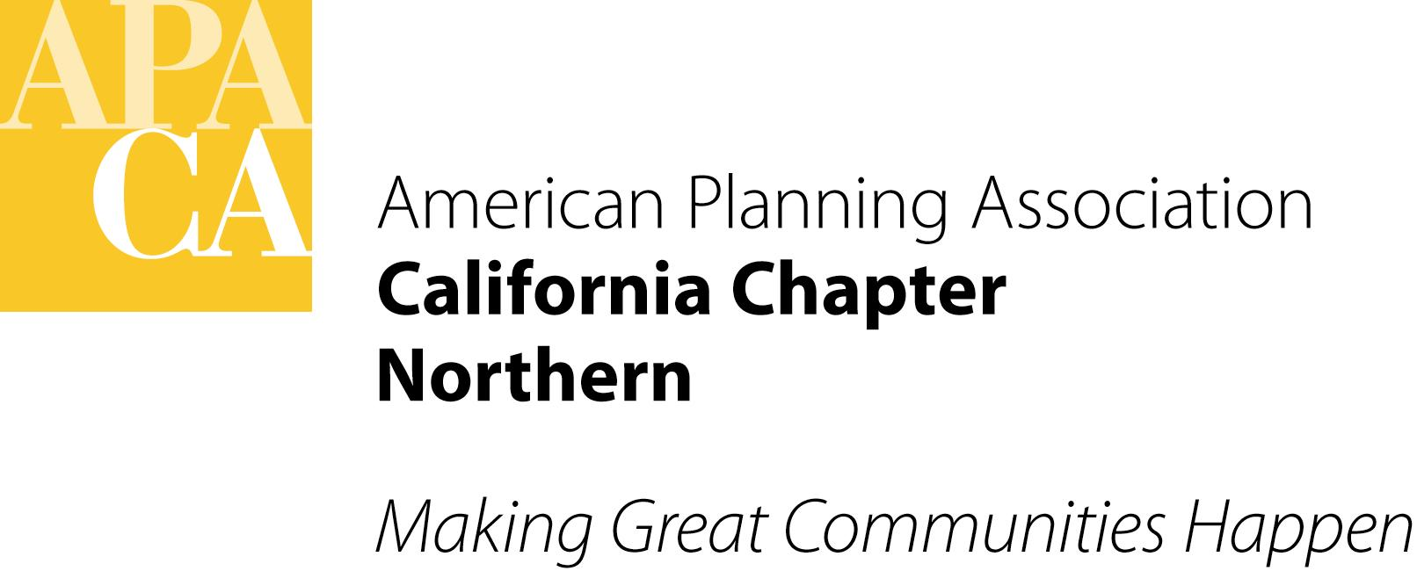APA California Northern
MENTORSHIP PROGRAM
2015 Mentor Application

Thank you for being willing to mentor planners and planning students. This Mentorship Program will run from January 2015 to October 2015. The following information will be used to help match you to mentees. Please attach your resume to this application. Participant applications are due to Thalia Leng, thaliah@gmail.com, by Tuesday, January 6, 2015. Visit the Section’s website (www.norcalapa.org) for more details on the Mentorship Program.

Name: APA Membership Number:
Email: Phone Number:
Home Address:
City: Zip Code:

Were you involved as a mentor in the previous Mentorship Program? Yes No
If yes, would you like to be matched up with your previous mentees? Yes No
What are you looking for in a mentee?

Do you have any geographic/time constraints? Yes No
If yes, please describe:
How far are you willing to travel to meet with a mentee? _____ miles
How do you rank the following (1 as most desired and 3 as least desired):
_____ proximity to mentees _____ align schedule with mentees _____ similar areas of expertise

EMPLOYMENT

Current Employer and Position:
Length of Time in this Position:

Previous Employer and Position:
Length of Time in this Position:

Previous Employer and Position:
Length of Time in this Position:

Education (Post High School)

School Attended:
Date Graduated: Degree Earned:

School Attended:
Date Graduated: Degree Earned:
APA California Northern Mentorship Program | Mentor Application – Page 2

Please describe your career and planning experience:

What kind of skills or knowledge can you offer in a mentoring relationship?

If selected to be a mentor, what are your goals for yourself and for your mentee?

Check all skills and knowledge areas in which you would be able to provide mentoring: (check all that apply)
Administrative
Business Development
Climate Change Planning
Communication
Community Development
Computers and GIS
Contracting
Economic Development
Energy Planning
Environmental Planning
Federal Planning
Grants
Historic Preservation
Housing
Local/Municipal Government
Long-term Planning
Permitting
Planning for the Disabled
Planning Law
Private Practice
Project Management
Public Participation
Regional Planning
Small Town & Rural Planning
Strategic Planning
Sustainability
Time Management
Transportation Planning
Urban Design
Waste Management

Other skills or knowledge area: (please specify)

